1. PLANET DATABASE
AIM
To write a Prolog program to create a Planet Database and retrieve planet information using Prolog queries.
OBJECTIVE
· To create a database of planets using Prolog facts.
· To store the name, type, and distance of planets from the Sun.
· To retrieve planet details using queries.
· To understand database searching in Prolog.
ALGORITHM
1. Start.
2. Define the predicate planet(Name, Type, Distance).
3. Store the planet details as facts.
4. Enter a Prolog query.
5. Search and match the required information in the database.
6. Display the matching planet details.
7. Stop.
FLOWCHART:
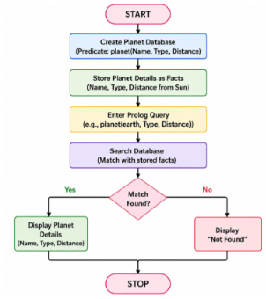
CODE:
planet(mercury, terrestrial, 57).
planet(venus, terrestrial, 108).
planet(earth, terrestrial, 150).
planet(mars, terrestrial, 228).
planet(jupiter, gas_giant, 778).
planet(saturn, gas_giant, 1430).
planet(uranus, ice_giant, 2870).
planet(neptune, ice_giant, 4495).
OUTPUT:
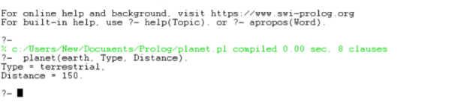
RESULT:
Thus, the Prolog Planet Database was successfully created, and the required planet information was retrieved using Prolog queries.

